**Project Details:**

- Project Statement: Implementing File Storage with EFS:

-Description: Create a scalable and shared file storage system using Amazon Elastic File System (EFS). Implementation: Set up an EFS file system, mount it to EC2 instances, and configure access permissions. Use it to share files across multiple instances.

-Name: G Pradeep swamy

ARCHITECTURE DIAGRAM:

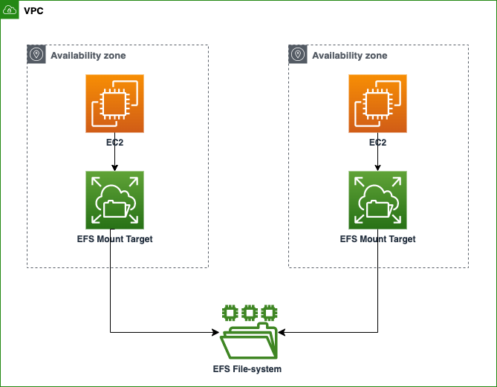

Step by step instruction:

1. Create a file system in EFS:

Go to EFS console >> create a file system (click on customize)

STEP 1

Name: name of your choice

Availability and durability: regional

Performance mode: general

Through output mode: Bursting

Performance settings: enhanced click next

Vpc: select default vpc

Mount targets: remove all default security groups and create a new security group, we will attach newly created security groups here

(To create new security go to ec2 console and create a new security group

Edit inbound rules, Allow port 22(Ssh) and port 2049 from anywhere)

Next step is File system policy, leave it as it is click next

Review and create a File System

(Now we have to mount this file system to our Instances, therefore create one or more instances in ec2 console,)

1. Creating one or more instances in ec2 console

Ec2 console>>create instances

Network settings >>edit it >select any 1 subnet say 1a

Select previously added security group

Configure storage >click edit >add shared file system>select your efs (copy the mount point for future use)

Launch instances

Follow and same step and create second instances, (just change subnet as 1b, and for security group, select same security group as used for 1st instances)

1. Test and review

Select 1st instance and connect it using ec2 instance connect

To verify your file use command as

ls /mns/efs/fs1/ ( this is mount point of our file)

To login as root user

sudo su

To add sample text file

echo “hello world”> /mnt/efs/fs1/hello.txt

To view the sample text file

cat /mnt/efs/fs1/hello.txt (you should see “hello world “ )

Now to cross verify files availability in different subnet

Select 2nd instances

Connect it into EC instant connect

Give commands:

cat /mnt/efs/fs1/hello.txt

(We should see “hello world “ )

It means that our EFS, sharing its files in both the instances,

By this task we understood that EFS is a completely managed elastic file system designed for use across different machines and availability zones

**PROJECT SUMMARY**

This project involves deploying Amazon Elastic File System (EFS) to provide shared file storage for two distinct EC2 instances, promoting collaboration and data consistency. The EFS solution ensures seamless file access and updates across both instances, enhancing the efficiency of the multi-instance environment.